Name ________________________________________ Date _______________________________ Period ____________
Sun-Moon-Earth Unit Study Guide
Key Vocabulary: Match each vocabulary term with its correct definition.
_____1. Rotation | a. the point in Earth’s orbit when it is closest to the Sun; occurs in January.
_____2. Revolution | b. Results in the highest high tides and lowest low tides of the month; occurs during new moon and full moon phases.
_____3. Solstice | c. Literally means “equal nights,” point in Earth’s orbit where both hemispheres receive equals amounts of daylight and night time.
_____4. Equinox | d. the point in Earth’s orbit when it is farthest away from the Sun; occurs in July.
_____5. Perihelion | e. the chemical reaction that produces the Sun’s energy
_____6. Aphelion | f. the point between to planetary bodies where their masses balance.
_____7. Precession | g. wobbling motion of Earth around the precessional axis; causes a ½ degree change in Earth’s tilt.
_____8. Nutation | h. Results in smaller differences between high and low tides because the Moon and Sun are not aligned with the Earth.
_____9. Spring Tide | i. chemical reaction that occurs on Earth that requires oxygen and results in the formation of water, carbon dioxide, and energy.
_____10. Neap Tide | j. the motion of Earth where Earth changes the direction of its axis without changing the angle of its tilt; this changes the stars near the North Pole.
_____11. Barycenter | k. the spinning motion of Earth on its axis; causes Earth’s day and night cycle.
_____12. Combustion | l. Earth’s orbital motion around the sun.
_____13. Nuclear Fission | m. chemical reaction that results in the splitting of atoms
_____14. Nuclear Fusion | o. the point in Earth’s orbit when either hemisphere receives the longest hours of sunlight or darkness.

Read to Learn!
Organization of the Universe
The solar system consists of the Sun, eight planets, some 60 or so moons, and assorted minor materials (asteroids, meteoroids, comets, dwarf planets, dust, and gas). All of these objects are tiny in comparison to the distances that separate them. Imagine the solar system scaled down such that distances to the planets could be spaced along a 10-kilometer hiking trail. On such a scale the Sun would be represented by a ball only 2.3 meters in diameter. Out of all the planets in the solar system, Earth is the only planet that scientists can study in detail.
The Milky Way Galaxy, or simply the Galaxy, is a typical example of a galaxy, a large, independent system of stars, star clusters, and interstellar material. Our Milky Way galaxy is made of 200-400 billion stars! By studying the Milky Way, we can better understand galaxies as a whole. The Milky Way can be identified as a spiral galaxy because of the pinwheel-shaped interstellar material that traces out a spiral pattern in the plane of the Galaxy. The Milky Way is only one of over 100 billion known galaxies that make up the entire Universe!
- Rank in order of size: galaxy, Universe, star, planet, solar system, Earth’s moon, star cluster
__________________________________________________________________________________________________
- Circle the items that are in our Solar System.
Star Comet Star Cluster Asteroid Galaxy Meteorite Pluto

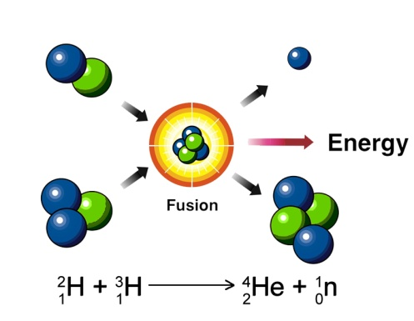
Solar Radiation
The Sun’s energy is generated in the solar interior by thermonuclear reactions involving the fusion of four nuclei of hydrogen to one nucleus of helium. Temperatures are high enough for this to occur only in the central 25 percent of the Sun, called the core. This generated energy transferred to Earth via radiation. The radiation from the Sun travels to Earth in many forms of electromagnetic waves.

- Describe how the sun generates energy and what elements are involved. ___________________________________________________________________________________________ ___________________________________________________________________________________________________________________________

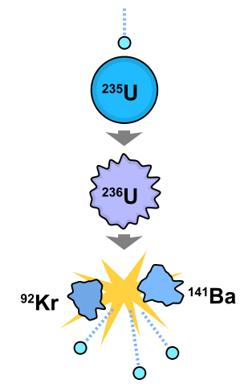
Nuclear Fission

In nuclear physics and nuclear chemistry, nuclear fission is either a nuclear reaction or a radioactive decay process in which the nucleus of an atom splits into smaller parts (lighter nuclei), often producing free neutrons and photons (in the form of gamma rays), and releasing a very large amount of energy. Currently, nuclear fission has occurred both in atomic bombs and in nuclear power plants on Earth.

Describe what is wrong with the following statement: Power Plants use nuclear fusion to split Uranium atoms, and the Sun does nuclear fission to combine hydrogen atoms into helium atoms. __________________________________________________________________________________________________________________________________________________________________________________________

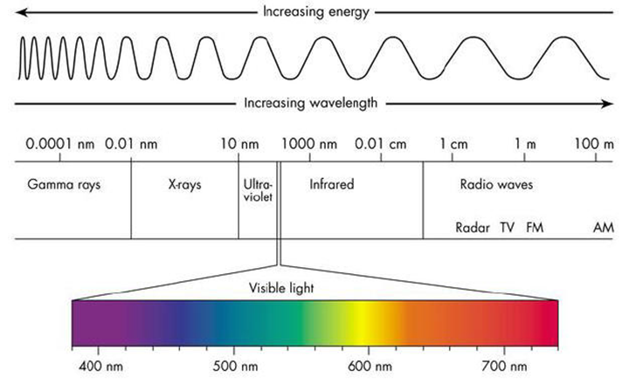
Electromagnetic Radiation (Light)
The second great area of physics necessary to address the universe is the subject of light, or electromagnetic radiation. Visible light is the relatively narrow frequency band of electromagnetic waves to which our eyes are sensitive. Wavelengths are usually measured in units of nanometers (1 nm = 10⁻⁹m). The colors of the visible spectrum stretch from violet with the shortest wavelength to red with the longest wavelength. However, electromagnetic radiation consists of more than just visible light; it also includes (from short wavelength to long wavelength) gamma-radiation, X-radiation, ultraviolet, visible, infrared (heat), microwaves, and radio waves.
- Compare the wavelength and energy of ultraviolet light with infrared light. ______________________________________________________________________________________________________________________________________________________________________________________
- If blue light has a wavelength of 500 nm, would you expect red light to have longer or shorter waves? Explain. ______________________________________________________________________________________________________________________________________________________________________________________

Earth’s Motion Earth moves through space in many ways.
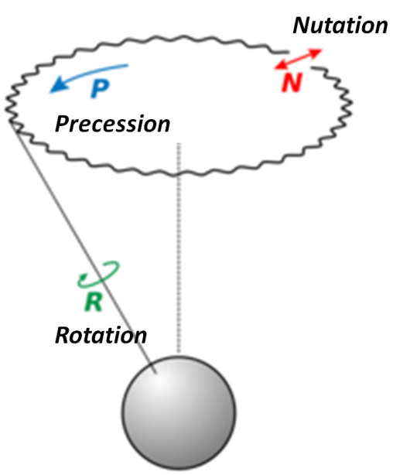
  - Rotation: Earth’s spin around its tilted axis. Results in the 24 hour day and night cycle.
  - Revolution: Earth’s 365 day orbit around the sun. Along with Earth’s 23.5 degree tilt, this motion is responsible for Earth’s changing seasons.
  - Precession: change in direction of the axis, but without any change in tilt—this changes the stars near (or not near) the Pole, but does not affect the seasons (as long as the angle of 23.5 degrees stays the same). Precession completes a full cycle every 26,000 years. The Earth’s shape is not a perfect sphere because of the pull from the Sun and the Moon on the equators. This bulge at the center of Earth causes its precession motion.
  - Nutation: wobbling around the precessional axis (This is a change in the angle—½ degree one way or the other. This occurs over an 18 year period and is due to the Moon exclusively. This would very slightly increase or decrease the amount of seasonal effects.)
- Which of Earth’s motions takes the longest amount of time to complete? ___________________________
- It takes Earth 24 hours to complete which motion? ______________________________________________
- Which motion can cause a slight change in the seasons? _________________________________________
- Which motion changes the stars that we see in the sky? __________________________________________
- Which motion means “orbit”? ____________________________________
- Which motions are due to the pull on the Moon? ________________________________________________

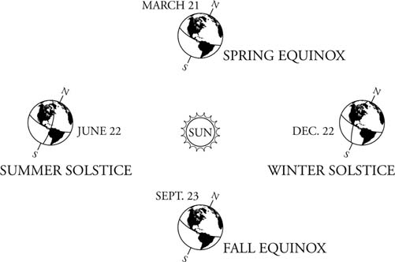
Seasons
The seasons on the Earth are not caused by how close the Earth is to the Sun. The Earth is closest to the Sun on or about January 1, and farthest away on or about July 1 each year. The reason for the seasons lies in the amount of the Sun's radiation that reaches the Earth.

So, does closeness to the Sun determine the seasons? Explain what does cause the seasons. __________________________________ _____________________________________________________________________________________________________________________________________________________________________

The seasons on Earth are caused by the 23.5° tilt of the axis of rotation. The summer begins on or about June 21, when the Sun is directly overhead at local noon on the Tropic of Cancer (23.5°N latitude). This is the Summer Solstice. Solstice means “Sun stands still” in Latin. All points above the Arctic Circle (66.5°N latitude) have 24 hours of sunlight; above the Antarctic Circle (66.5°S) all points have 24 hours of darkness. In the United States, the Sun rises north of due east and sets north of due west. As it reaches the noon position, it is in the southern part of the sky. For an observer in the United States, the Sun is never directly overhead. The opposite occurs at about December 21, the first day of winter (Winter Solstice). The Sun is directly overhead at the Tropic of Capricorn (23.5° S latitude). The North Pole experiences total darkness, whereas the South Pole is in total light. For an observer in the United States, the Sun rises south of due east and sets south of due west.
The equinoxes (“equal night”) fall on or about March 21 (Vernal Equinox) and September 23 (Autumnal Equinox). The Sun is directly overhead at the Equator and the entire Earth has 12 hours of day and night. The Sun rises directly in the east and sets directly in the west.
Over the course of a year, the Sun reaches its highest point on June 21 for anyone living north of the Tropic of Cancer. The maximum air temperature for this area is delayed until July. The reason is similar to the daily changes. The ground needs time to absorb the energy and to reradiate it to the atmosphere. On the other end of the year, the Sun reaches its lowest noontime point on December 21. For the same reasons as above, the coolest month for the region is January.
- Write a complete sentence using the following terms: Daylight, Summer Solstice, Hemisphere
______________________________________________________________________________________________________________________________________________________________________________________
- Write a complete sentence using the following terms: Equinox, Equator, Sunlight Angle
______________________________________________________________________________________________________________________________________________________________________________________
- The shortest day of the year is December 21st, why isn’t this the coldest day of the year also?________________ ______________________________________________________________________________________________________________________________________________________________________________________
- The Diagram below represents the position of the earth at various times of the year in its orbit around the sun. Point out at least 5 errors in the diagram.
  - _______________________________
_______________________________
  - _______________________________
_______________________________
  - _______________________________
_______________________________
  - _______________________________
_______________________________
  - _______________________________
_______________________________
1. Label the 8 phases of the moon below. In the box at right 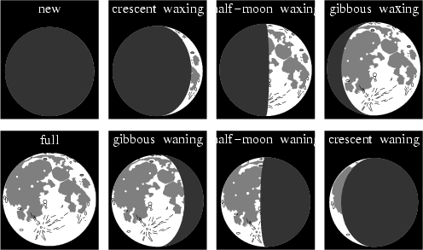

Earth

Sun
Draw in the moon at each phase. Don’t forget to shade in the dark side of the moon, and label each moon with the number that corresponds to its phase seen on Earth.

1. 2. 3. 4.
5. 6. 7. 8.

Tidal Forces
The most direct consequence of the gravitational interaction between two objects is their mutual orbit around their center of mass, the point where their masses balance, called the barycenter. Sun is not stationary in our solar system. It actually moves as the planets tug on it, causing it to orbit the solar system's barycenter. The Sun never strays too far from the solar system barycenter.

- A student says, “The moon orbits around the center of Earth.” Explain why this student’s statement is not correct. Use the word “barycenter” in your answer. ________________________________________________ ______________________________________________________________________________________________________________________________________________________________________________________

Almost everyone is aware of the role that gravity plays in our lives. Not only does it keep our feet planted firmly on the ground, but it also keeps order in the solar system. The gravitational forces associated with the Sun and the planets interact to describe the orbits that we are familiar with, as well as keep the Moon trapped in orbit around the Earth. These forces aren't only limited to managing the dynamics of the celestial bodies, however. Gravity also has a more directly observable influence on our planet. Specifically, gravitational forces are responsible for the rise and fall of the ocean's tides all over the world.
The two primary agents when it comes to the motion of the ocean are the Sun and the Moon. Since the gravitational influence of an object is directly related to its mass, the Sun has a definite advantage over the moon when it comes to the strength of its forces. However, since the Sun is over 380 times farther away from the Earth than the Moon, the smaller mass in orbit around us is able to exert its effects on us much more strongly than the star.
- What two objects in space affect Earth’s changing tides? _________________________________________
- Which object has the greatest effect and why? _________________________________________________ ______________________________________________________________________________________
The key when it comes to understanding how the tides work is to understand the relationship between the motion of our planet and its moon. Both the Moon and the Earth are constantly moving through space. Since the Earth spins on its own axis, water is kept balanced on all sides of the planet through centrifugal force. The Moon's gravitational forces are strong enough to disrupt this balance by accelerating the water towards the Moon. This causes the water to 'bulge.' The Earth's rotation causes a sympathetic bulge on the opposite side of the planet as well. The areas of the Earth where the bulging occurs experience high tide, and the others are subject to a low tide. However, the Moon's movement around the Earth means that the effects of its forces are in motion as well, and as it encircles our planet, this bulge moves with it.

The Moon's influence can also be balanced out by the position of the Sun – if the Sun and the Moon find themselves 90 degrees apart in relation to an observer on the Earth, then high tides are not as high as they normally would be. This is because despite its greater distance from the planet, the Sun's mass allows it to exert enough gravitational force on the oceans that it can negate some of the effects of the Moon's pull. This phenomenon of lower high tides is called a neap tide. In the same way, when the Sun lines up with the Moon and the Earth, as during a Full Moon, then the Sun can act to amplify the tidal forces, drawing even higher tides. These are known as spring tides, named not for the season, but for the fact that the water "springs" higher than normal. The variance in the height of the world's tides also depends on the local geography of the coastline and the topography of the ocean floor.
- Describe the position of the Sun, Moon, and Earth during a neap tide. __________________________________ ___________________________________________________________________________________________
- Draw the two possible positions of the Sun, Moon and Earth during a Neap tide.

- What phases of the moon do we see on Earth during a neap tide? ________________ and __________________

- Describe the position of the Sun, Moon, and Earth during a spring tide. ________________________________ ___________________________________________________________________________________________
- Draw the two possible positions of the Sun, Moon and Earth during a spring tide.

- What phases of the moon do we see on Earth during a spring tide? _______________ and ________________

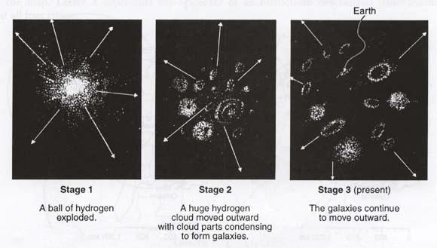
- Describe what is happening in each stage of the image above. _________________________________________________________________________________________________________________________________________________________________________________________________________________________________________________________________________________

Define the following terms on a separate sheet of paper and attach it to this packet.
- Nutation
- Precession
- Barycenter
- Neap Tides
- Spring Tides
- Ellipse
- Waning
- Waxing
- Gibbous
- Crescent
- Solar Eclipse
- Lunar Eclipse
- Seasons
Also, list the planets in order and annotate whether they have moons, rings or any other distinguishing features (Hint: think big storms or no atmosphere as distinguishing).

