Name _____________________________________________________ Date _______________________ Prd ______
Introduction to Earth Science Study Guide

Unit Vocabulary: Match the vocabulary word with its definition.
______1. Hydrosphere | - Represents three-dimensional landscapes by using contour lines to show elevation change on the surface of the earth
______2. Atmosphere | - Distance North and South of the equator
______3. Biosphere | - Ratio written in fraction form that can change a measurement from one unit to another.
______4. Lithosphere | - Difference in elevation represented by each contour line
______5. Latitude | - All the life on earth
______6. Longitude | - The layer of gases around Earth’s surface.
______7. Time Zones | - Lines on a map that represent equal elevation
______8. Topographic Map | - All the water on earth
______9. Contour Line | - The distance East and West of the Prime Meridian
______10. Contour Interval | - Zero degrees latitude
______11. Metric System | - Method of measurement based on series of 10. Uses the meter for length, the kilogram for mass, and the second for time.
______12. Conversion Factor | - All of the cool, rocky zones of Earth’s geosphere.
______14. Equator | - Zero degrees longitude
______15. Prime Meridian | - Region on Earth with the same standard time. Earth is divided into 24 of these regions, each representing 1 hour of the day.

The Earth’s Spheres
Our planet formed 4.5 billion years ago. Since then, it has developed and modified four main physical environments that interact strongly with one another.
- _______________: The layer of gases that surrounds the Earth. The atmosphere protects us from the sun’s intense heat and radiation, provides the air we breathe, and produces weather.
- _______________: The Earth’s water. The hydrosphere includes all the liquid and frozen water of the Earth’s oceans and land (groundwater), as well as water vapor in the atmosphere.
- _______________: All organisms living on and inside the Earth’s surface.
- _______________: The rigid, relatively cool rocky zone immediately under the Earth’s surface. The lithosphere and geosphere include the Earth’s crust and part of the upper mantle.

Show what you know!
Directions: Read the scenarios below and write down which of the Earth’s spheres is affecting another of the Earth’s spheres. (Example: “The hydrosphere is affecting the biosphere”)
- An apple tree releases oxygen gas from its leaves. _________________________________________
- An earthquake causes a tsunami in the Indian Ocean. _______________________________________
- A snake digs a hole underground to hibernate. ____________________________________________
- A volcano erupts, releasing a lot of ash and gases. _________________________________________
- Hurricane Katrina floods New Orleans. _________________________________________________
- Hot summer air makes a lot of water evaporate from a lake. __________________________________

Match the sphere associated with each of the following scenarios. Some may have more than one answer.
A. Hydrosphere
B. Atmosphere
C. Lithosphere
D. Biosphere
- __________: Pollution from a chemical plant leeches into a river
- __________: Erosion from a glacier breaks down bedrock
- __________: Ocean acidification causing coral bleaching
- __________: Air pollution causing complications in the ozone layer
- __________: Human traffic through national parks destroying plant life
- __________: Volcanic ash polluting the air
- __________: Weathered rock causing turbidity in a local creek
- __________: A turtle choking on plastic from a landfill
- __________: A hurricane (just in general)
- __________: Mining in a coal mine
- __________: Deforestation in the tropical rainforest
- __________: Contamination in drinking water
- __________: Overgrazing in a prairie
- __________: A forest fire
- __________: Regrowth after a forest fire
- __________: Humans have an impact on…

Topographic Maps

Contour lines are lines that are drawn on a map to connect all the points of equal elevation on the map. These lines give a great picture of the lay of the land. The resulting map is called a Topographic Map.

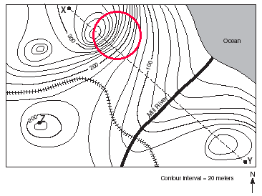
Rules to remember when reading topographic maps:

Close lines = Steep slope

The steepest slopes on the map can be seen by looking for lines that are very close together. Since each line represents a change in elevation of a set amount (20 meters in this example), lines that are close together indicate steep gradients. The circled is very steep, because it has many lines crowded close together.

Contour lines bend upstream when crossing a river

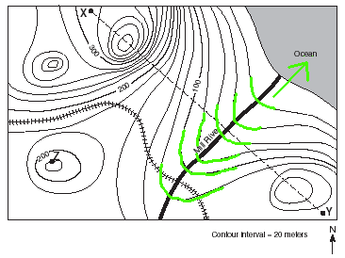
Since contour lines must remain at the same elevation, they must bend when they cross riverbeds. A riverbed drops downward, so the contour line must bend uphill to stay at the same elevation. The highlighted lines show that the direction of the Mill River must be northeast.

A profile is a picture of what the landscape would look like from the side. It is a cross section of the landscape. You should be able to identify a correct profile, as well as draw one. How could we depict the profile from point X to Point Y?

Determine the elevation of Point X to be above 300 m.

Next, determine the elevation of Point Y to be above 120 m.

We can tell from the two circular areas on the map (one near point X and one near point Y) that there will be two hills in the profile.

The resulting profile will look like the one pictured here.

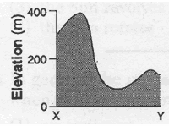

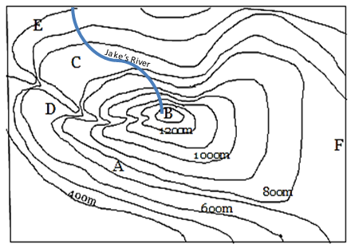
Show what you know!

What is the contour interval of the map shown above? Explain. ____________________________________________________________________________

What is the elevation at point E? __________________________

Could the elevation at peak B be 1410 m? Explain your reasoning. __________________________________________ ________________________________________________________________________

What is the difference in elevation between points A and B? _______________________

Could the elevation at point F be 417 m? Explain your reasoning. _______________________________________________________________________________ _________________________________________________________________________ __________________________________________________________________

In which general direction is Jake’s river flowing? __________________________

Just looking at the map, would it be easier to head down from peak B going North or going East? Explain your reasoning. _________________________________________________________________________________ __________________________________________________________________________________________

Match the following topographic maps to their corresponding profiles.

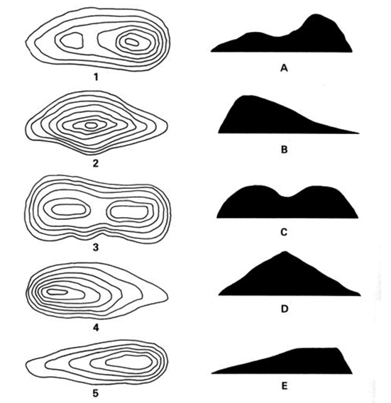

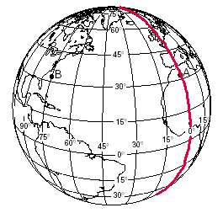
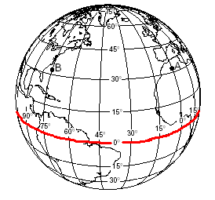
Latitude and Longitude

This is the coordinate system that we use on Earth. It is measured in units of degrees.

_______________is the angular distance north or south of the equator. The equator is the middle location on the Earth's surface, and is located halfway between the North and South poles.

_______________is the angular distance east or west of the Prime Meridian. The Prime Meridian is designated as 0 degrees longitude, and passes through Greenwich, England.

Show What You Know!

Shade in the other latitude lines on the globe on the left.

Label the Equator in the appropriate place.

Write an N next to all the lines North of the equator and an S next to all the lines South of the equator. (Hint: You will have more N’s than S’s.)

Shade in the other longitude lines on the globe on the right.

Label the Prime Meridian in the appropriate place.

Write a W next to all the lines West of the Prime Meridian and an E next to all the lines East of the Prime Meridian. (Hint: You will have many more W’s than E’s.)

Summarize how latitude and longitude lines are drawn on a globe of Earth. ______________________________________________________________________________________________________________________________________________________________________________________________________________________________________________________

Find the coordinates (latitude and longitude) of Point A on the globe. ___________________________

What Continent is Point A located in? ___________________________________

Find the coordinates for Point B on the globe. _____________________________________

What ocean is Point B located in? ____________________________________________

Draw a star at 0°, 60°W. What continent did you draw your star on? ____________________________
- Identify the following major locations by their longitude or latitude.
  - Greenwich, England: _______________________________________
  - The North Pole: ___________________________________________
  - The Tropic of Capricorn: ____________________________________
  - The South Pole: ___________________________________________
  - The Equator: _____________________________________________
  - The Tropic of Cancer: ______________________________________
  - The Prime Meridian: _______________________________________
h. The International Date Line: __________________________________
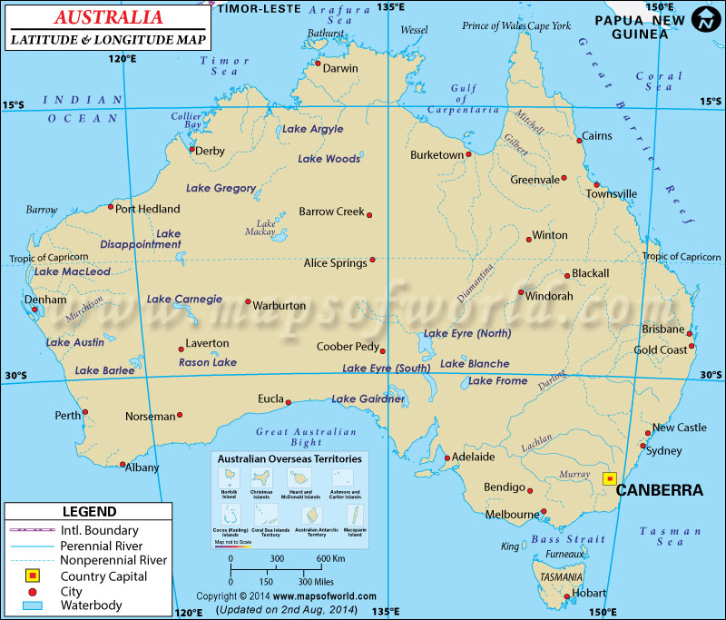
- What is the most effective way to model our planet? Why is it difficult to show landmasses on a flat map without having them look distorted?

- Use the map of Australia provided above to answer the following questions:
- What is the latitude of Sydney? _______________________________
- What is the Longitude of Albany? _____________________________
- What is the capital of Australia? What are its coordinates? _________
- At what latitude is the most northern tip of Lake Carnegie located? ___________
- The northernmost city shown on the map is: _____________________
- The westernmost city shown on the map is: ______________________
- Australia is ________________________ of the Prime Meridian and ___________________________ of the Equator.
- What city on this map lies on the Tropic of Capricorn? _____________
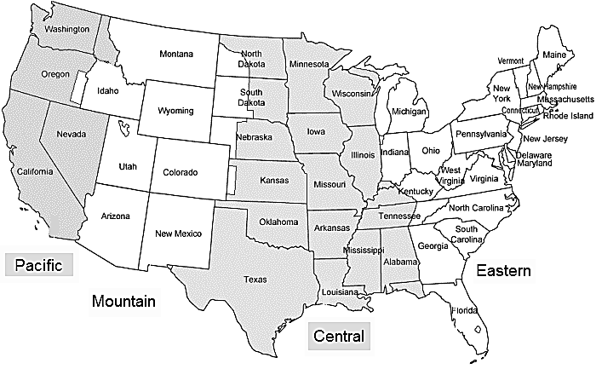

Time Zones

Earth is divided into 24 time zones. Each zone represents a different hour. The international date line, or 180° meridian, is the transition for calendar days. Large countries, such as the United States, are often split up into multiple time zones. The United States has 6 time zones, including Alaska and Hawaii.

According to the map shown, what time zone is Greensboro, NC in?

_____________________________

If it’s 8:55 am in Florida, What time is it in Colorado? _________________________

If it’s noon in Nevada, what time is it in Greensboro? ________________________

Explain why this time zone map of US is incomplete according to the text above. ____________________________________________________________________________________________________________________________________________________________________

Metric Measurements
A conversion factor is a ratio written in fraction form that can express the same value or quantity in two different units.

We can make two unit factors from this information:

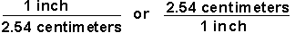

Now, we can solve some problems. Set up each problem by writing down what you need to find with a question mark. Then set it equal to the information that you are given. The problem is solved by multiplying the given data and its units by the appropriate unit factors so that only the desired units are present at the end.

Sample Problem 1: How many centimeters are in 6.00 inches?

Sample Problem 2: How many inches are in 24 cm?

Now let’s try a problem using more than one conversion factor:

Sample Problem 3: How many seconds are in two years?
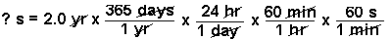

Now try some problems with metric conversions.
1 kL = 1000 L = 1  1000 L 1 kL | 1 gram = 100 cg = 1  100 cg 1 gram | 1 meter = 1000 mm = 1  1000 mm 1 meter | 1 day = 24 hours = 1  24 hours 1 day
1) 27.37 meters to centimeters = ___________________________________________________________________
2) 835,300 centimeters to meters = ___________________________________________________________________
3) 74.54 meters to millimeters = ___________________________________________________________________
4) 159,860 millimeters to meters = ___________________________________________________________________
5) 94.35 kilometers to meters = ___________________________________________________________________
6) 9,880 meters to kilometers = ___________________________________________________________________
7) 43.29 centimeters to millimeters = ___________________________________________________________________
8) 31,701 millimeters to centimeters = ___________________________________________________________________
9) 19.83 kilometers to centimeters = ___________________________________________________________________
10) 173,200 centimeters to kilometers = ___________________________________________________________________
11) 53.27 kilometers to millimeters = ___________________________________________________________________
12) 22,000 millimeters to kilometers = ___________________________________________________________________
13) 6.16 liters to milliliters = ___________________________________________________________________

